**Accreditation & Credit Designation Statements**

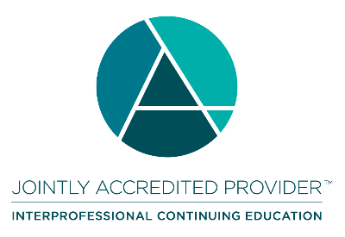**Joint Accreditation Statement**In support of improving patient care, the American Society of Addiction Medicine is jointly accredited by the Accreditation Council for Continuing Medical Education (ACCME), the Accreditation Council for Pharmacy Education (ACPE), and the American Nurses Credentialing Center (ANCC), to provide continuing education for the healthcare team.

**Physicians**The American Society of Addiction Medicine designates this enduring material for a maximum of **16** *AMA PRA Category 1 Credits™*. Physicians should claim only the credit commensurate with the extent of their participation in the activity.

**Pharmacology Hours**

This activity has **8** number of hours that satisfy the requirements for NP and PA Pharmacology Hours.

**California Association for Drug/Alcohol Educators (CAADE)**This educational program is approved by CAADE: #CP40 999 1225.

**California Association of DUI Treatment Centers (CADTP)**This educational program is approved by CADTP: #205.

**California Consortium of Addiction Programs and Professionals (CCAPP)**This educational program is approved by CCAPP: #OS-20-330-1224.

**Other Professions - Continuing Education Credits**Upon completion of the activity and online evaluation, all other participants may request a certificate of participation. Participants may submit this certificate of participation to their professional organization/institute as documentation for completing this accredited continuing activity.

**Maintenance of Certification (MOC) or Continuing Certification Programs (CCP)**

MOC Credit is reported for ABA, ABP, ABIM, and ABS. By completing the online credit application and evaluation, the learner permits ASAM to report credits to the appropriate Board. [Learn more](https://elearning.asam.org/certifications-and-moc-explore-all).

**American Board of Anesthesiology (ABA) – With Patient Safety**This activity offers up to 16 CME credits, of which 16 credits contribute the patient safety CME component of the American Board of Anesthesiology’s redesigned Maintenance of Certification in AnesthesiologyTM (MOCA®) program, known as MOCA 2.0®. Please consult the ABA website, [www.theABA.org](http://www.theABA.org), for a list of all MOCA 2.0 requirements.

**American Board of Internal Medicine (ABIM)**Successful completion of this CME activity, which includes participation in the evaluation component, enables the participant to earn up to 16 Medical Knowledge MOC points and patient safety MOC credit in the American Board of Internal Medicine's (ABIM) Maintenance of Certification (MOC) program. Participants will earn MOC points equivalent to the amount of CME credits claimed for the activity. It is the CME activity provider's responsibility to submit participant completion information to ACCME for the purpose of granting ABIM MOC credit.

**American Board of Pediatrics (ABP)**

Successful completion of this CME activity, which includes participation in the evaluation

component, enables the learner to earn up to 16 MOC points in the American Board of

Pediatrics’ (ABP) Maintenance of Certification (MOC) program. It is the CME activity provider’s

responsibility to submit learner completion information to ACCME for the purpose of granting ABP

MOC credit.

**American Board of Surgery (ABS)**

Successful completion of this CME activity, which includes participation in the evaluation component, enables the learner to earn credit toward the CME and Self-Assessment requirement(s) of the American Board of Surgery’s Continuous Certification program. It is the CME activity provider's responsibility to submit learner completion information to ACCME for the purpose of granting ABS credit.