Accreditation & Credit Designation Statements

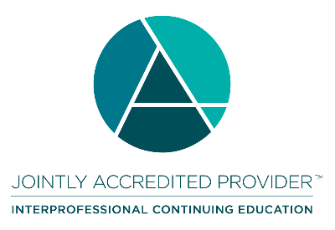
Joint Accreditation Statement
In support of improving patient care, the American Society of Addiction Medicine is jointly accredited by the Accreditation Council for Continuing Medical Education (ACCME), the Accreditation Council for Pharmacy Education (ACPE), and the American Nurses Credentialing Center (ANCC), to provide continuing education for the healthcare team.
Physicians
The American Society of Addiction Medicine designates this Journal Article CME/CE Activity for a maximum of 1 AMA PRA Category 1 Credits™. Physicians should claim only the credit commensurate with the extent of their participation in the activity.
Nurses
This activity awards 1 Nursing contact hours.
Pharmacy
This activity will offer 1 pharmacy contact hours (1 CEUs). Pharmacists will be asked to provide identifying information (e-Profile ID and DOB in MMDD format) in order to receive credit and allow reporting to CPE Monitor. (UAN: JA0000141-0000-24-064-H99-P)
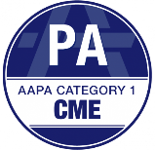
PAs
ASAM has been authorized by the American Academy of PAs (AAPA) to award AAPA Category 1 CME credit for activities planned in accordance with AAPA CME Criteria. This activity is designated for 1 AAPA Category 1 CME credits. Approval is valid until 06/04/2027. PAs should only claim credit commensurate with the extent of their participation.

Pharmacology Hours
This activity has 1 number of hours that satisfy the requirements for NP and PA Pharmacology Hours.

Social Workers
As a Jointly Accredited Organization, ASAM is approved to offer social work continuing education by the Association of Social Work Boards (ASWB) Approved Continuing Education (ACE) program. Organizations, not individual courses, are approved under this program. Regulatory boards are the final authority on courses accepted for continuing education credit. Social workers completing this course receive 1 general continuing education credits.

Interprofessional Continuing Education (IPCE) Credits
This activity was planned by and for the healthcare team, and learners will receive 1 Interprofessional Continuing Education (IPCE) credit for learning and change.

California Association for Drug/Alcohol Educators (CAADE)
This educational program is approved by CAADE: #CP40 999 1225.
California Association of DUI Treatment Centers (CADTP)
This educational program is approved by CADTP: #205.
California Consortium of Addiction Programs and Professionals (CCAPP)
This educational program is approved by CCAPP: #OS-20-330-1224.
Continuing Education Credits (CEUs)
Upon completion of the activity and online evaluation, all other participants may request a certificate of participation. Participants may submit this certificate of participation to their professional organization/institute as documentation for completing this accredited continuing activity.

Maintenance of Certification (MOC) or Continuing Certification Programs (CCP)
This activity meets the requirements for MOC/CCP for the following primary physician boards and for state licensing CME requirements. MOC Credit is only reported for ABA, ABP, ABIM, and ABS. By completing the online credit application and evaluation, the learner permits ASAM to report credits to the appropriate Board. Learn more.
- American Board of Medical Specialties (ABMS)
- American Board of Preventive Medicine (ABPM)
- American Board of Internal Medicine (ABIM)
- American Board of Pediatrics (ABP)
- American Board of Surgery (ABS)
- American Board of Psychiatry and Neurology (ABPN)
- American Board of Addiction Medicine (ABAM)
- Royal College of Physicians and Surgeons of Canada (RCPSC)
  - Through an agreement between the Accreditation Council for Continuing Medical Education and the Royal College of Physicians and Surgeons in Canada, medical practitioners participating in the Royal College MOC Program may record completion of accredited activities registered under the ACCME’s “CME in Support of MOC” program in Section 3 of the Royal College’s MOC Program.

Disclosure Information
In accordance with the disclosure policies of ASAM and Joint Accreditation, the effort is made to ensure balance, independence, objectivity, and scientific rigor in all accredited continuing education activities. These policies include identifying and mitigating all relevant financial relationships with ineligible companies for those involved in the creation and dissemination of accredited continuing education.
The planners, faculty, or those in control of creating or disseminating this accredited continuing education have no relevant financial relationships.

